Q.1 WAP to convert Fahreinheit to Celsius in java using formula given below

C=(f-32)/(9/5)

package assignment5;

import java.util.Scanner;

public class que1 {

public static void main(String[] args) {

// **TODO** Auto-generated method

System.***out***.println("enter the temperature in fahrenheit");

float temp=s.nextFloat();

float temp2=(temp-32)*5/9;

System.***out***.printf("the temperature in celsius is :%5.2f",temp2);

s.close();

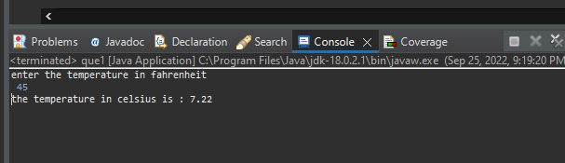

**Q2 wap to check a given number is armstrong or not i.e. 153 = 1*1*1 + 5*5*5+3*3*3**

package assignment5;

import java.util.Scanner;

public class Que2 {

public static void main(String[] args) {

// **TODO** Auto-generated method stub

Scanner s=new Scanner(System.***in***);

System.***out***.println("Enter the number");

int a=s.nextInt();

int temp=a;

int b,c;

int sum=0;

while(a>0)

{

b=a%10;

c=b*b*b;

sum=sum+c;

a=a/10;

}

a=temp;

if(a==sum) System.***out***.println("Given number is armstrong");

else System.***out***.println("Given number is not armstrong");

s.close();

}

}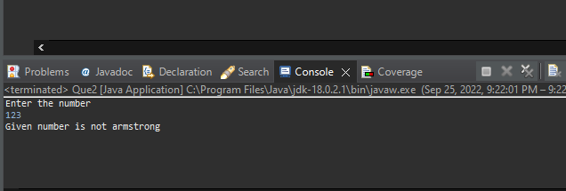

**Q3.rajan went to a movie with his friends in a multiplex theatre and during break time he bought pizzas puffs and cold drinks .consider the following prices:**

**Rs.100/pizza**

**Rs.20/puff**

**Rs.10/colddrink**

**Generate the bill of what rajan bought.**

public class que3 {

public static void main(String[] args) {

// **TODO** Auto-generated method stub

Scanner sc=new Scanner(System.***in***);

System.***out***.println("Enter the no of pizzas bought:");

int a =sc.nextInt();

System.***out***.println("Enter the no of puffs bought:");

int b =sc.nextInt();

System.***out***.println("Enter the no of cool drinks bought:");

int c= sc.nextInt();

System.***out***.println("Bill Details");

System.***out***.println("no of pizzas"+ a);

System.***out***.println("No of puffs:"+ b);

System.***out***.println("No of cooldrinks:"+ c);

System.***out***.println("Total price="+(a*100+ b*20+ c*10));

sc.close();

}

}

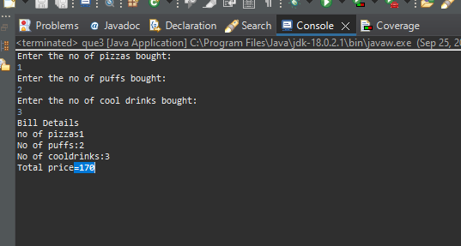

**Q4. Given an integer U denoting the amount of kwh units of electricity consumed ,the task is to calculate the electricity bill with the help of the below charges :**

**1 to 100 units : Rs 10/units**

**100 to 200 units :rs 15/units**

**200 to 300 units :rs 20/units**

**Above 300 units – rs 25/units**

package assignment5;

import java.util.Scanner;

public class que4 {

static float Bill_details(float x)

{

if(x>=1 && x<=100)

{

return (x*10);

}

else if(x>100 && x<=200)

{

return ((x-100)*15+1000);

}

else if(x>200 && x<=300)

{

return ((x-200)*20+2500);

}

else

{

return ((x-300)*25+4500);

}

}

public static void main(String[] args) {

Scanner s=new Scanner(System.in);

System.out.println("Enter the amount of KWh units of electricity you have consumed");

float unit=s.nextInt();

System.out.println("Your bill is: "+Bill_details(unit));

s.close();

}

}

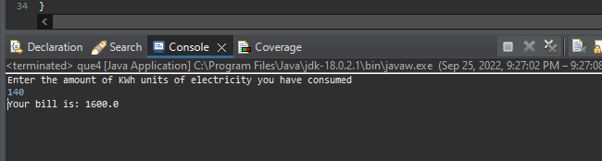

**Q5. Write a java program that define a sorted array of size N and an integer K,find the position at which K is present in array using binary search**.

package assignment5;

import java.util.Arrays;

java.util.Scanner;

public class que5 {

public static void main(String[] args) {

// TODO Auto-generated method stub

Scanner s=new Scanner(System.in);

System.out.println("Enter the 5 numbers");

int a[]=new int[5];

for(int i=0;i<a.length;i++)

{

a[i]=s.nextInt();

}

Arrays.sort(a);

System.out.println("Enter the number you want to search");

int n=s.nextInt();

System.out.print("Sorted array is : ");

for(int e:a)

{

System.out.print(e+" ");

}

int count=0;

int first=0;

int last=a.length-1;

int mid=(first+last)/2;

while(first<=last)

{

if(a[mid]<n) first=mid+1;

else if(a[mid]==n)

{

System.out.println("\nRecord found at index of : "+mid);

count=1;

break;

}

else last=mid-1;

mid=(first+last)/2;

}

if(count==0) System.out.println("\nRecord not found");

s.close();

}

}

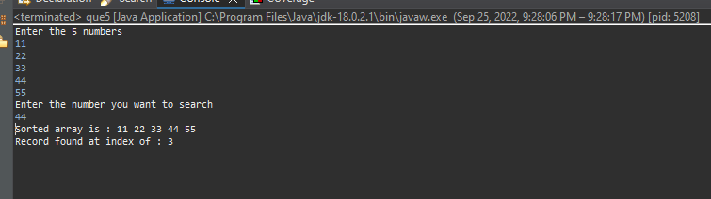

**Q6 write a java program and define n array ,print all the elements which are leaders .A leader is an element that is greater than all the elemennts on its right side in the array**

package assignment5;

import java.util.Scanner;

public class que6 {

public static void main(String[] args) {

// **TODO** Auto-generated method stub

Scanner s=new Scanner(System.***in***);

int a[]=new int[6];

System.***out***.println("Enter 6 numbers");

for(int i=0;i<a.length;i++)

{

a[i]=s.nextInt();

}

int leader=a[a.length-1];

System.***out***.print("Leaders : ");

System.***out***.print(leader+" ");

for(int i=a.length-2;i>=0;i--)

{

if(leader<a[i])

{

leader=a[i];

System.***out***.print(leader+" ");

}

}

s.close();

}

}

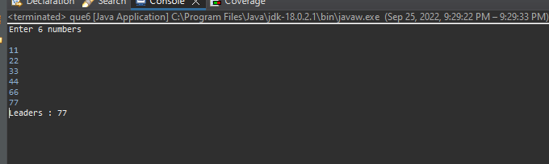

**Q7 Given two strings a and b consisting of lowercase characters .the task is to check weather two given strings are an anagram of each other or not .**

package assignment5;

import java.util.Arrays;

import java.util.Scanner;

public class que7 {

public static void main(String[] args) {

// TODO Auto-generated method stud

Scanner s=new Scanner(System.in);

System.out.println("Enter the 1st word");

String a=s.nextLine();

System.out.println("Enter the 2nd word");

String b=s.nextLine();

char c[]=a.toCharArray();

char d[]=b.toCharArray();

Arrays.sort(c);

Arrays.sort(d);

if(Arrays.equals(c, d)) System.out.println("Strings are anagram");

else System.out.println("Strings are not anagram");

s.close();

}

}





